AEG St. Louis Chapter Newsletter
December 2018

Please forward to others you know who may be interested.

*****
Visit www.aegstl.org, our website for the AEG St. Louis Chapter!

*****
Upcoming AEG St. Louis Chapter Meetings, Speakers, and Field Trips

Wednesday, December 5, 2018 - AEG St. Louis Chapter Meeting - Presentation by Terry McCleary of McCleary Engineering. Topic: “Geotechnical Engineering: Public vs Private.” Location: Syberg’s (2430 Old Dorsett Rd, Maryland Heights, MO 63043). See below for additional information.

January 2019 - AEG St. Louis Chapter Winter Break - The AEG St. Louis Chapter will not hold a chapter meeting in January 2019.

Wednesday, February 6, 2018 - AEG St. Louis Chapter Student Night - Short presentations by Anna Saindon of Geotechnology and Phyllis Steckel of Earthquake Insight. Resume review and mock interviews for students. Location: Geotechnology, Inc. (11816 Lackland Road, Suite 150, St. Louis, MO 63146). See below for additional information.

*****
December Chapter Meeting
The December Chapter Meeting will be held on Wednesday, December 5 at 5:30 PM at Syberg’s (2430 Old Dorsett Rd, Maryland Heights, MO 63043). Terry McCleary of McCleary Engineering, will share his presentation titled “Geotechnical Engineering: Public vs Private.” Cost will be $30 for members, $40 for non-members, and $10 for students and those between jobs. Please RSVP at http://www.aegstl.org/monthly-section-meetings/ by Tuesday, December 4, 2018.

A special thanks to Kaskaskia Engineering Group (KEG), the sponsor for our December meeting!
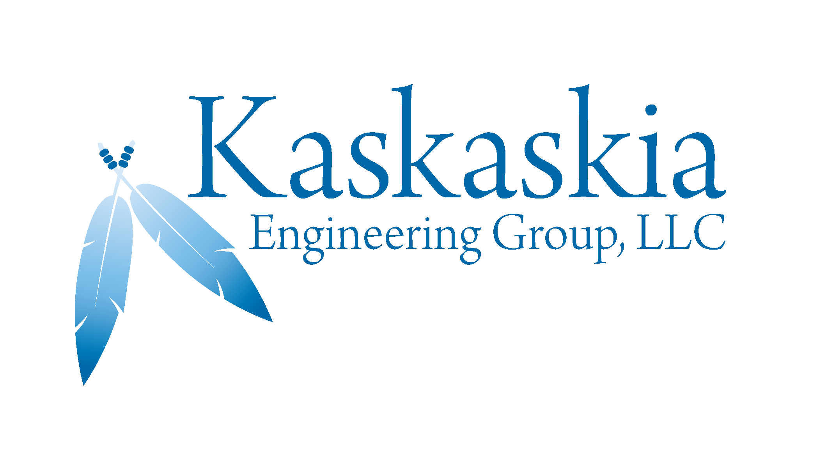
KEG is a certified DBE. Our services include transportation, traffic, geotechnical, and structural engineering; CADD design; environmental science; construction observation; infrastructure planning; right-of-way research and acquisition; and water resource management.

*****
2019 Student Workshop at Geotechnology
The Student Workshop was previously scheduled for September 2018, but was postponed to spring 2019 due to inclement weather.

Geotechnology will host the Biennial Subsurface Exploration Student Workshop at their office on Saturday, April 6, 2019. The workshop will be from 9:30am to 4:00pm. The cost is $10 per student. See the attached announcement for additional information and the link to register.

If you would like to help with the event, contact Jessie Goodwin (jgoodwin@geotechnology.com).

*****
HAZWOPER 40-Hour Training Course
The Missouri Waste Control Coalition (MWCC) has contracted with Nova Consulting Group, Inc. to provide a 40-hour HAZWOPER Training consistent with OSHA's Hazardous Waste Operations and Emergency Response standard (29 CFR 1910.10 and 1925.65). The training will be January 7-11, 2019 in the Roaring River/Bennett Springs Conference Room, Missouri Department of Natural Resources Headquarters, 1730 E Elm Street, Jefferson City, MO.

The registration fee is only $50 per registrant. Class is limited to the first 50 participants. A waiting list will be available in the event of cancellations. All registrants must be employees of a Missouri state or local government agency, or companies that work in Missouri or a student at a Missouri school.
Registration is now open on the MWCC’s website, http://mowastecoalition.org.

*****
AEG St. Louis Chapter Student Night - February 2019
The St. Louis Chapter’s Student Night will take on a new format this year. The meeting will include short professional presentations by Anna Saindon of Geotechnology (topic TBD) and Phyllis Steckel of Earthquake Insight (“The Little River Drainage District: The Largest Civil Engineering Project in Missouri that No One has Ever Heard Of”).

The evening will include resume reviews and mock interviews for students. Please contact Stephanie Kline-Tissi (klinestephaniej@gmail.com) if you would like to volunteer to help with resume reviews or mock interviews. The meeting will be held at Geotechnology, Inc. (11816 Lackland Road, Suite 150, St. Louis, MO 63146). Employers: Please use this as an opportunity to snatch up interns and soon-to-be-grads before the Career Fairs begin!

*****
AEG Coastal Hazards Symposium: Engulfing the Coast
AEG will hold a three-day Coastal Hazards Symposium January 7-10, 2019. at the Dauphin Island Sea Lab (DISL) on Dauphin Island in Alabama. Online registration is open until December 21, 2018. Additional information on the event, registration, lodging, and submitting abstracts is available here.

*****
AEG St. Louis Chapter Sponsors Needed
The AEG St. Louis Chapter is looking for sponsors for our 2019 meetings. Sponsorships are $300 per meeting. Please contact Ed Jones for more information (ejones@geosyntec.com)

Benefits of being a Meeting Sponsor include: a 20-30 word summary in the newsletter, one or two PowerPoint slides to run on the slide-show loop that is projected in the dining room during the networking and dinner time, and if a representative of the sponsoring company attends the meeting, he or she will have two to three minutes to talk about their organization. Brochures, giveaways, table-top displays, and business cards are certainly welcome as well.

*****
Employment: Job Seekers & Open Positions

Smith & Co. Engineers, of Poplar Bluff, MO, has an opening for entry level environmental scientists (geologist/biologist/engineer). Please contact Mike Walker, RG (573-785-9621 or mikew@shsmithco.com) for more information.

To all Jobseekers and Employers – Please contact the newsletter editor, Jessie Goodwin (jgoodwin@geotechnology.com), to post your search for an employer or employee, and when you have found a new job or filled an advertised position. This helps us keep our postings accurate and timely.

*****
AEG St. Louis Chapter Officers
Stephanie Kline-Tissi, Chair (klinestephaniej@gmail.com)
Matt Masterson, Vice Chair (mmasterson@kaskaskiaeng.com)
Ed Jones, Treasurer (ejones@geosyntec.com)
Jessie Goodwin, Secretary (jgoodwin@geotechnology.com)
Phyllis Steckel, Past Chair (psteckel@charter.net)

Midwest Regional Director: Mimi Garstang (dgarstang@kc.rr.com)

